KORbuild

Bids — Overview
KORbuild product guide
Bids is how one company invites others to bid on a scope of work, compares the bids and awards one — all inside KORbuild. The company that hires is the contracting company: a general contractor hiring subcontractors, or a subcontractor passing part of its work to another one (subcontracting). The invited companies are subcontractors: with a KORbuild account they bid from Measure; without one, they bid through a private link.
The award is what links the two companies on the job. From then on, everything that already works between companies works on its own: the general contractor approves the subcontractor's daily reports, follows its crew on site (without dollar amounts) and receives its published schedule (see How KORbuild is organized).
Bids come with the plan, like Settings. They are not a separate module.

Why it matters
- One place for the whole bid. Package, invitations, answers, questions, bids, leveling and award — no spreadsheets and email threads to reconcile.
- Each company sees only its own. An invited subcontractor never sees who else was invited, the others' amounts or the winning amount.
- Leveling that tells the truth. A cost code without a price shows as not bid, never as zero; an exclusion that is in your included scope is flagged before you award.
- The award creates the job link. The winner creates its job from the won project and it is already linked to yours.
- A channel that stays. Questions during the bid become the job conversation after the award. Nothing is edited or deleted.

Who takes part
Who | Where | What they do
Contracting company (admin, project manager) | Daily › Bids | Builds the package, invites, answers questions, levels the bids, awards.
Subcontractor with KORbuild (admin, estimator) | Measure › Invitations | Opens the invitation, bids or declines, measures in a project created from it and submits through the platform.
Subcontractor without KORbuild | A private link | Sees the invitation, answers, asks and submits the bid PDF with the total. No account needed.
Upstream contracting company | Its own bid | When it asked for it, approves the company its subcontractor wants to hire.

The main screens
Screen | What it shows
Bids (Daily) | Every bid the company sent: open, ready to award, drafts, awarded, with the due date and how many bids arrived.
New bid | The package: job, scope of work, cost codes, included and excluded scope, drawings, due date, budget, requirements and invitees.
The bid | Tabs Invitees, Questions, Level bids and Details; actions Extend, Invite more, Cancel.
Invitations (Measure) | The invitations the company received, with the contracting company and the due date.
The invitation | The package, I'll bid / Decline, the questions and your bids.
The link page | The same invitation, without signing in, with the bid form.
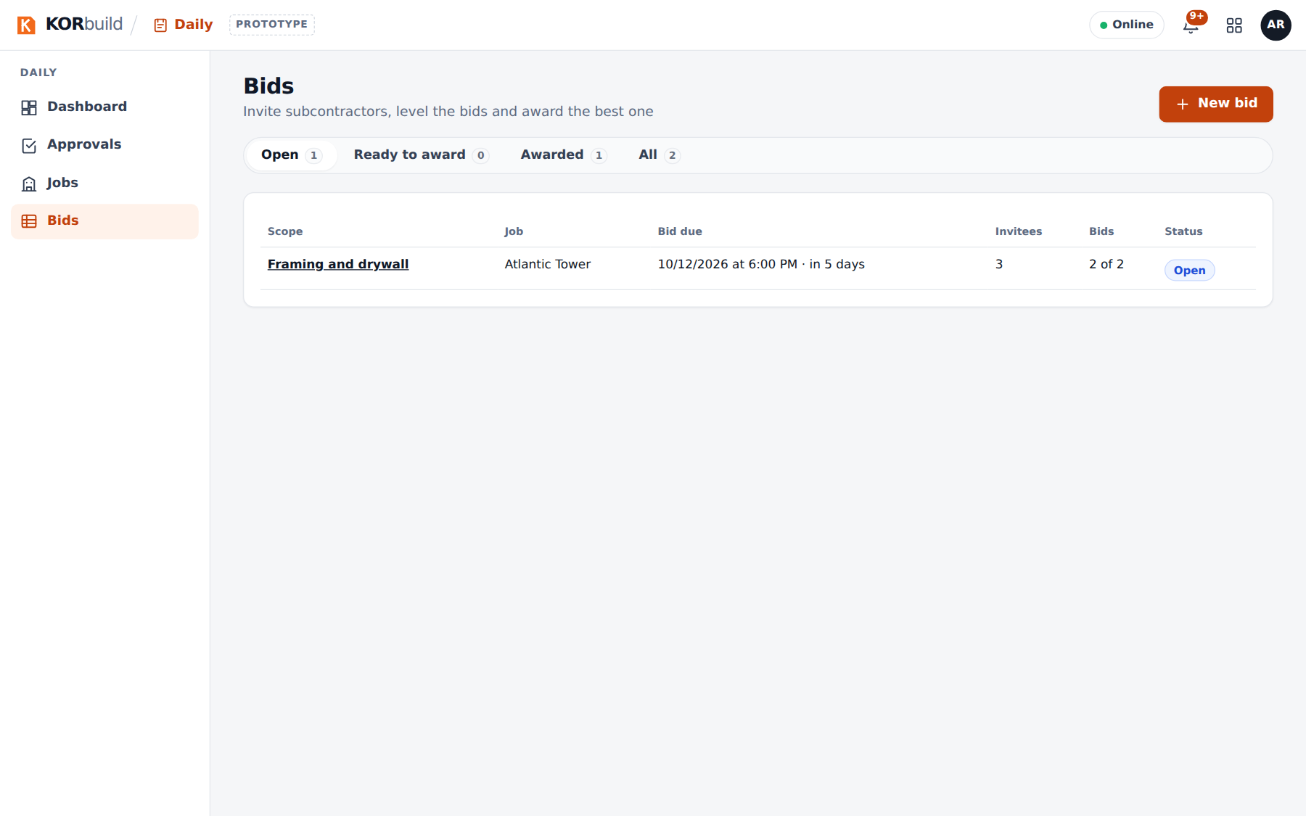
The bid list
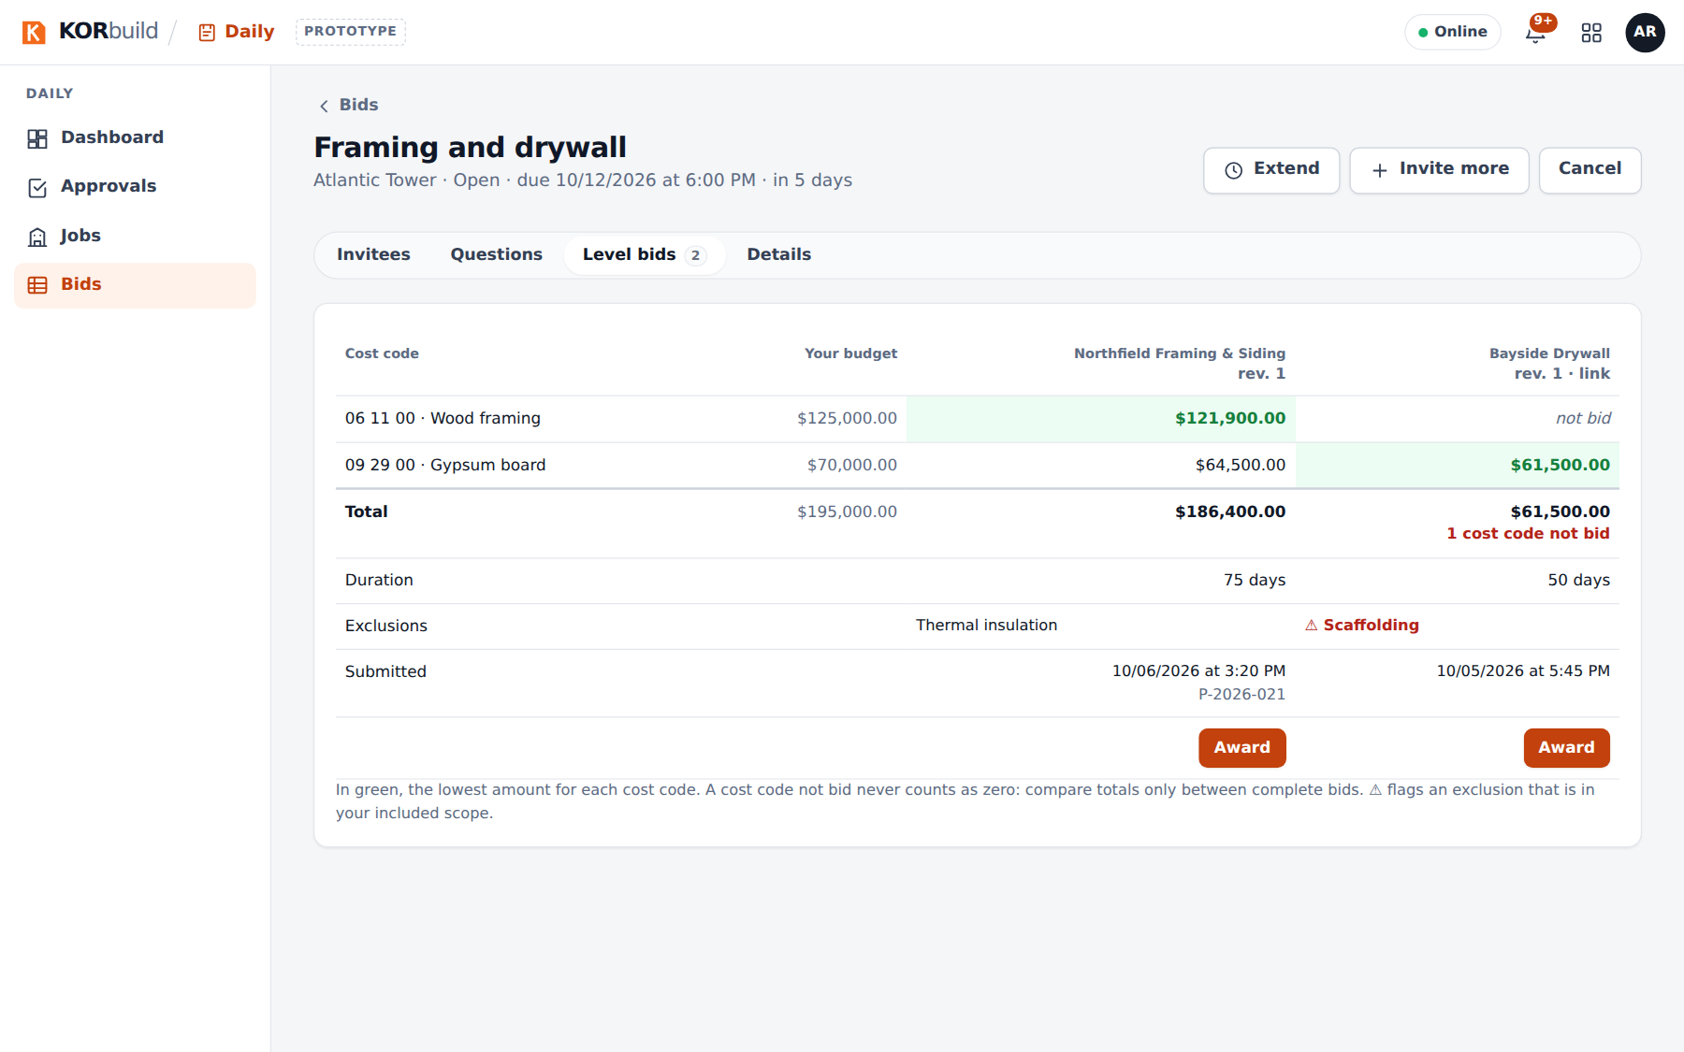
Leveling the bids

How a bid goes
Step | What happens
1. Package | The contracting company describes the scope, picks the cost codes and the due date, and chooses the invitees from its Contacts.
2. Invitations | Each invitee gets it in KORbuild (with an account) or by a private link (without one).
3. Answer | I'll bid creates a project in Measure; Decline can carry a reason.
4. Questions | Through the channel; each answer goes to all invitees (without saying who asked) or only to who asked.
5. Bids | Submitted through the platform, by cost code. Each new one is a revision; nothing is edited.
6. Leveling | Side by side, by cost code, with duration, exclusions and requirements.
7. Award | The bid closes; the others are told they were not selected, without the amount.
8. Job link | The winner's project becomes Won, its job is created linked to yours, and the channel continues.

Subcontracting
A subcontractor can also be the contracting company. It can get sub bids while estimating (from its Measure project, using their prices in its own estimate) or after winning (from its job). Each link in the chain sees only its neighbors; dollar amounts never cross a link. The general contractor sees who is on site from the whole chain, without amounts. See the user manual.

